Emily Lane

HIED 801 Week 8 Application Exercise

March 22, 2020

**Note: My answers are in bold**

Problem #1

In Lesson 8 you were asked to calculate a 95% confidence interval using the mean and standard deviation from Lesson 7 for 36 die rolls. Submit your written calculations for the confidence intervals.

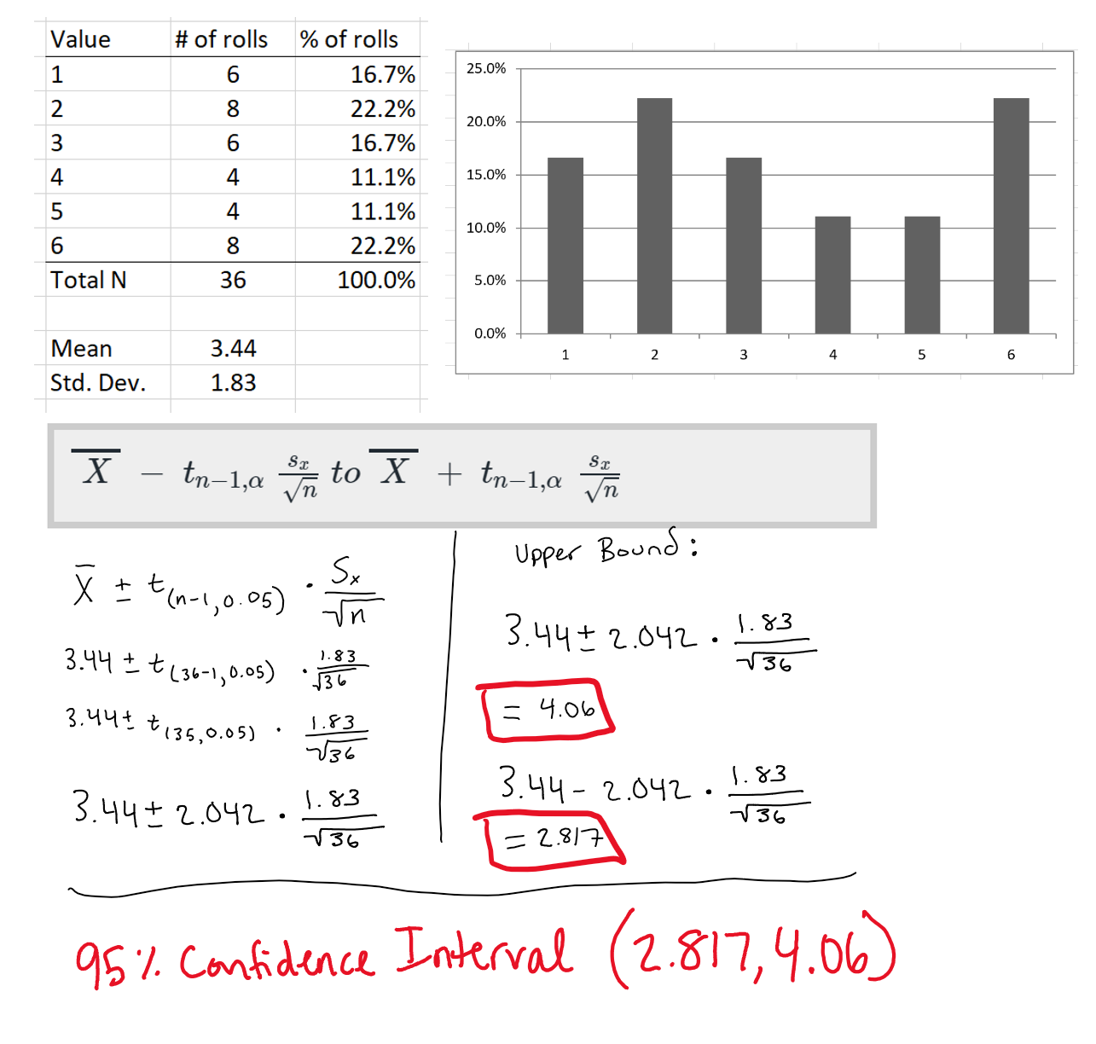

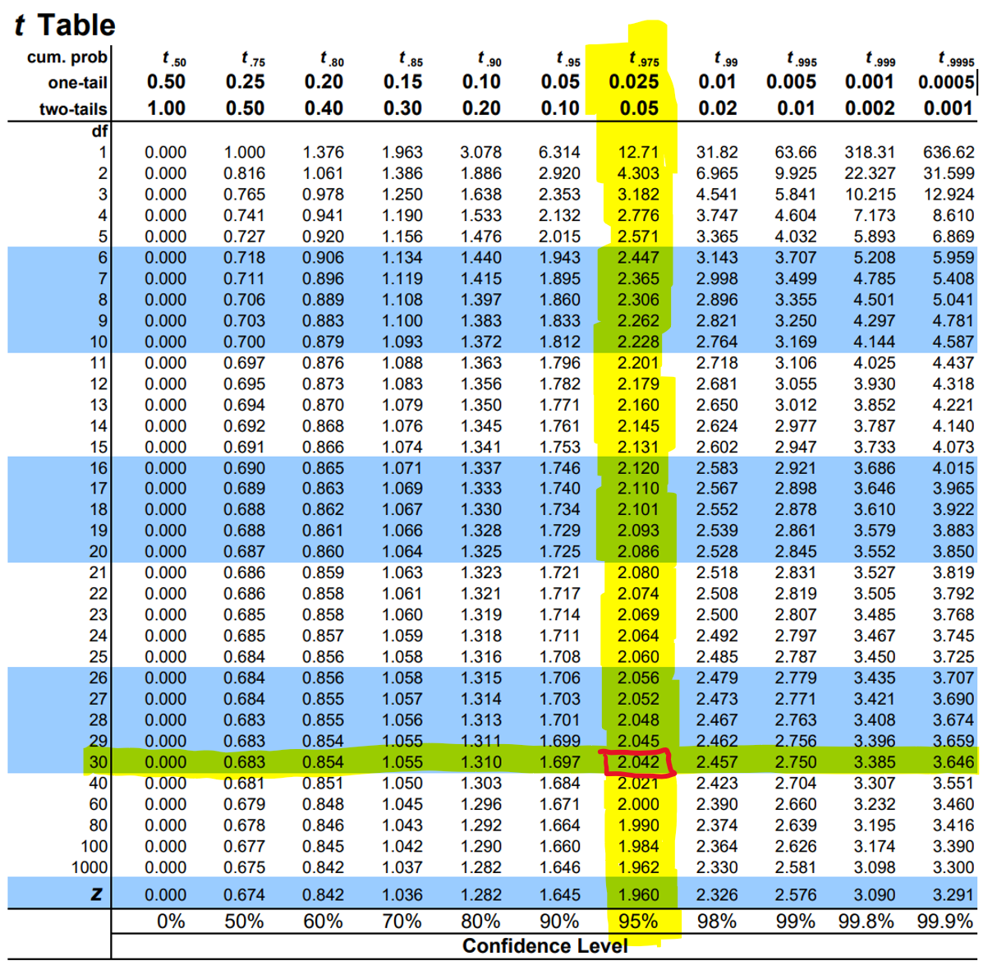

Problem #2

Consider the following scenario:

You are tasked with examining whether the first-year GPA of in-state students differs from the first-year GPA of out-state students. You have access to confidence intervals of the difference between the average in-state first-year GPA and the average out-state first-year GPA. (Note: A difference of 0 means that the in-state first-year GPA sample mean is identical to the out-state first-year GPA sample mean.)

1. If the confidence interval was (-0.18, 0.31), would you state that substantial differences between these groups appear to exist? Why?

* **No, because the confidence interval contains the value zero. In other words, zero is a possible value of the true population difference.**

1. If the confidence interval was (0.25, 0.73), would you state that substantial differences between these groups appear to exist? Why?

* **Yes, because the confidence interval does not contain the value zero. In other words, we have evidence that suggests that the true difference in first-year GPA among in-state and out-state students is between 0.25 and 0.73**

Problem #3

Consider the following scenario:

You are participating within a task force that is examining gender differences in academic performance among undergraduate students. You are the only member of the task force with an understanding of statistics. For each of the below cases, provide a general description of the statistical findings and discuss what they might mean regarding the degree to which male and female students differ in their academic performance.

1. Average GPA for male students: 2.99; Average GPA for female students 3.02; Sample size: 22,234 male students and 24,153 female students; t-statistic: 3.32; p-value 0.001.

* **The observed mean GPAs for female and male students as reported by this study are very similar to each other, however, because each sample size is very large, the observed difference between female and male GPAs is unlikely to have occurred by randomness or chance alone. Since the t-statistic is 3.32 and the p-value is 0.001, we can conclude there is sufficient evidence that the population GPAs of males and females differ.**
* **Since this is a two-sided test, because the alternate hypothesis is that the GPA’s *differ*, we could only conclude that there is a difference in males and females’ GPA.**

1. Average GPA for male students: 2.94; Average GPA for female students 3.07; Sample size: 133 male students and 151 female students; t-statistic: 1.81; p-value 0.08.

* **The observed GPAs for male and female are further apart than the previous example, however, the sample sizes are much smaller. This means that the differences in GPA for the two groups could have occurred simply by chance alone.**
* **Based off the t-statistic which is 1.81 and the p-value which is 0.08, there is insufficient evidence to suggest that the population mean GPAs for males and females differ.**

[Note: The null hypothesis for the t-statistic and p-value is that male and female students have identical GPAs while the alternative hypothesis is that their GPAs differ.] (2 sided test)

Problem #4

Consider the following scenario:

You were asked to conduct a benchmarking report that compares the business school at your institution to the business schools at other institutions. When analyzing the results for schools within your Carnegie classification, you notice that business schools with the smallest numbers of students were disproportionately present among lists of the lowest performers. A colleague tells you that this evidence demonstrates that business schools require a critical mass of students in order for their students to thrive.

Is there an alternative explanation for this finding? What is that explanation?

**The difference in performance between schools with the smallest number of students versus the largest number of students within schools in my Carnegie classification could be for a number of reasons.**

* **When dealing with samples with fewer students, the figures will have more variability which means that it is expected to see a disproportionate amount of business schools with the smallest number of students on the list of schools with the lowest performers. This is because small samples yield extreme results more than large samples do.**

**Some more natural answers for this question are as follows:**

* **Schools that are not famous for their business school might have a lower number of students enrolled in their business school. Naturally, these students enrolled in the lower ranked business school will perform at a lower level than the students who are enrolled in higher ranked business schools.**
* **Higher ranked business schools will have a higher volume of applications and have their choice of the top performing students.**
* **Higher ranked business schools will have more qualified faculty and perhaps more outside industry support.**
* **Schools with a lower number of students might have a lower financial revenue from tuition and fees. This could affect the resources available to students.**

**In other words, the reason for the lower performance may not be due to the fact that there are fewer students, but actually due to other potential variables.**