Student Charges Personal Reflection

HIED 545

Emily Lane

**Meredith College Student Charges:**

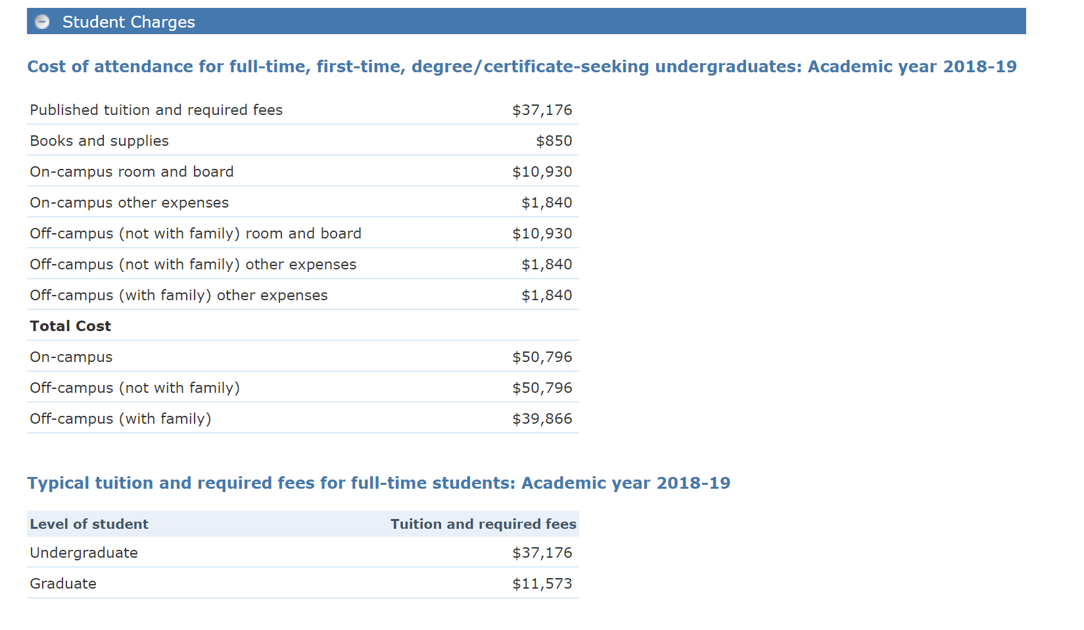

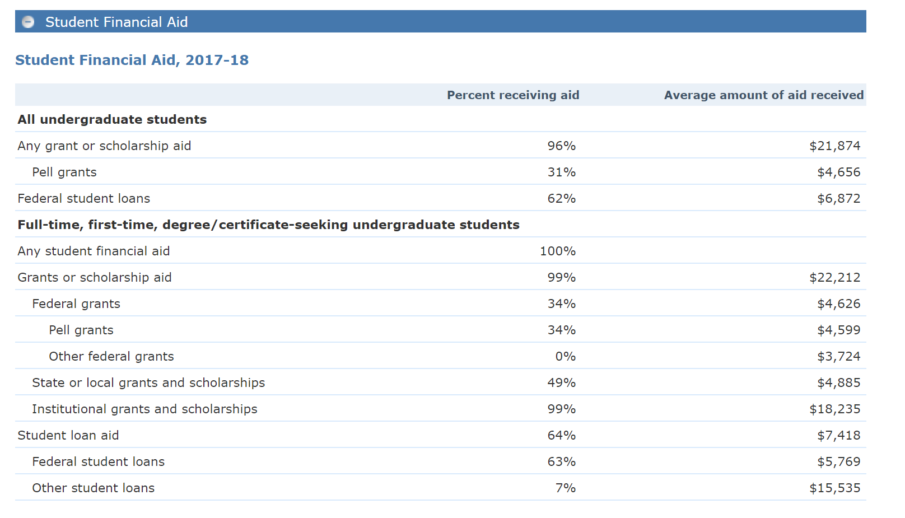

I reviewed cost and financial aid data from IPEDS for Meredith College.

It is distinctive that 96% of students receive grants or scholarship aid, and 64% of students utilize student loan aid. This makes sense as the yearly living expense and tuition and fees in 2017-2018 were $50,796. Financial aid is surely necessary to recruit students to Meredith College with such high tuition. It is also distinctive that 7% of students receive an average amount of $15,535 in other student loans. This is a substantial financial burden that students must face in the future. There are also opportunities for first-generation or financially underprivileged students through 34% of students being Pell Grant recipients.

This data indicates that Meredith College likely recruits both students who can afford the college, and “cost-sensitive" students by reducing the sticker price for most students. There are also many scholarships from various departments within the college which could be an attempt to recruit students with specific interests and talents into their programs.

As yearly tuition is quite high and there are financial aid packages available, it is likely that most students must weigh the potential benefits of a liberal arts education at Meredith with the future burden of debt.

I learned a lot from the discussion posts. I really appreciate the direct comparison of two-year degree student charges versus four-year degree student charges. It put a lot of perspective on the financial benefits of taking advantage of transfer agreements between a student’s local community college and the surrounding four-year institutions. This discussion is also the first time I viewed residential institutions through a financial lens. It is surprising how much the cost of living on-campus could add up, and I wonder if the requirement would cause financial stress for students.

Reflecting again on Meredith College’s student charges after evaluating many of my peer’s institutional student charges, I notice that 31% of students receiving Pell Grants is slightly above average for a private, four-year institution. Regarding all students who receive any grant or scholarship aid, Meredith is substantially above the other institutions reported in the discussion with 96% of students at Meredith college receiving aid. Of the four-year institutions mentioned, Penn State has the next highest percent of students receiving any grant or scholarship aid with 64%.