Prediction Scenario Assignment  
Emily Lane  
HIED 801 Week 11

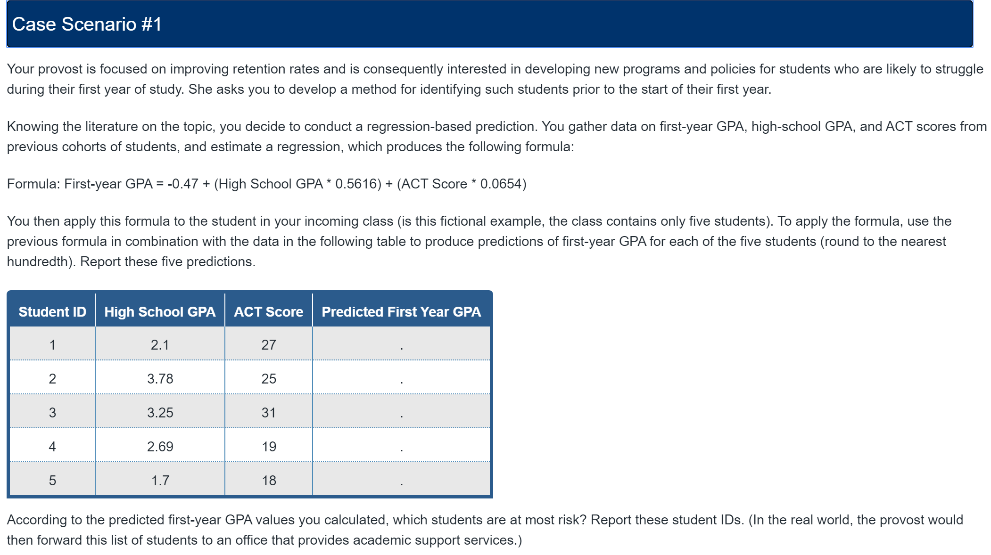

I applied the corresponding values to the variables in the regression formula:

Formula: First-year GPA = -0.47 + (High School GPA * 0.5616) + (ACT Score * 0.0654)

I got the following values:

|  |  |  |  |
| --- | --- | --- | --- |
| **Student ID** | **High School GPA** | **ACT Score** | **Predicted First Year GPA** |
| **1** | 2.1 | 27 | 2.48 |
| **2** | 3.78 | 25 | 3.29 |
| **3** | 3.25 | 31 | 3.38 |
| **4** | 2.69 | 19 | 2.28 |
| **5** | 1.7 | 18 | 1.66 |

According to the predicted first -year GPA values calculated, Student 5 is most at risk with a predicted first year GPA of 1.66. Student 4 is also at risk as their predicted first year GPA is 2.28.

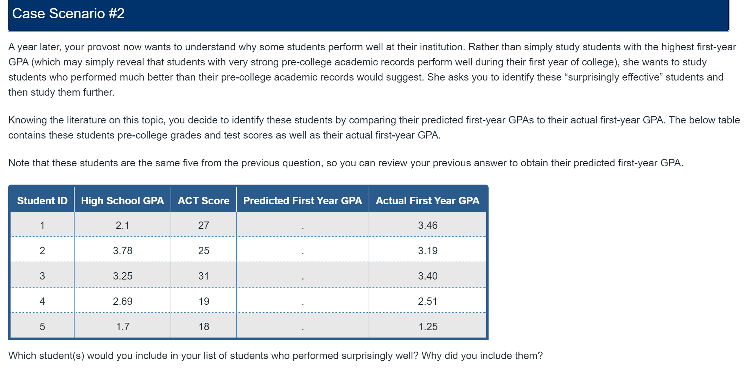

|  |  |  |  |  |
| --- | --- | --- | --- | --- |
| **Student ID** | **High School GPA** | **ACT Score** | **Predicted First Year GPA** | **Actual First Year GPA** |
| 1 | 2.1 | 27 | 2.48 | 3.46 |
| 2 | 3.78 | 25 | 3.29 | 3.19 |
| 3 | 3.25 | 31 | 3.38 | 3.4 |
| 4 | 2.69 | 19 | 2.28 | 2.51 |
| 5 | 1.7 | 18 | 1.66 | 1.25 |

When comparing the five student’s predicted first year GPA to their actual first year GPA, Student 1 exceeded their predicted first year GPA by 0.98 points, and student 4 exceeded their predicted first year GPA by 0.23 points.

Student 1 performed surprisingly well as they jumped almost an entire GPA point from their predcited GPA. This is a significant difference than the predicted value.

Student 4 performed better than their predicted GPA, but it is only slightly better than predicted, so I would not describe it as truly “surpring” or significant.

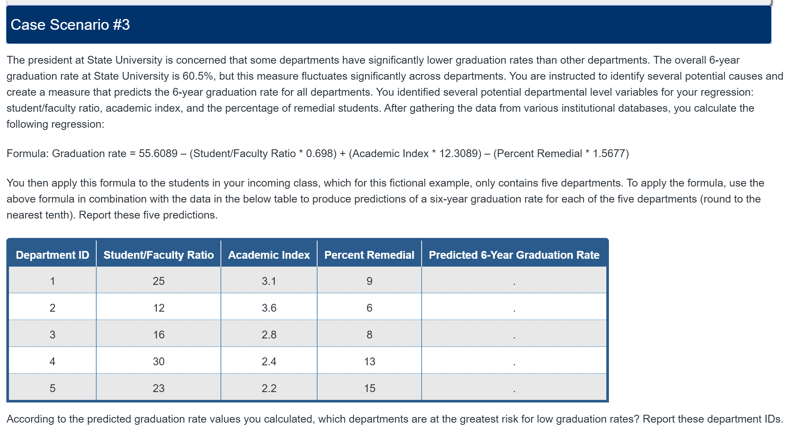

I applied the corresponding values to the variables in the regression formula:

Formula: Graduation rate = 55.6089 – (Student/Faculty Ratio * 0.698) + (Academic Index * 12.3089) – (Percent Remedial * 1.5677)

I got the following values:

|  |  |  |  |  |
| --- | --- | --- | --- | --- |
| **Department ID** | **Student/Faculty Ratio** | **Academic Index** | **Percent Remedial** | **Predicted 6-Year Graduation Rate** |
| 1 | 25 | 3.1 | 9 | 62.2 |
| 2 | 12 | 3.6 | 6 | 82.1 |
| 3 | 16 | 2.8 | 8 | 66.4 |
| 4 | 30 | 2.4 | 13 | 43.8 |
| 5 | 23 | 2.2 | 15 | 43.1 |

According to the predicted graduation rate values calculated from the given regression formula, Departments 4 and 5 are at the greatest risk for low graduation rates.

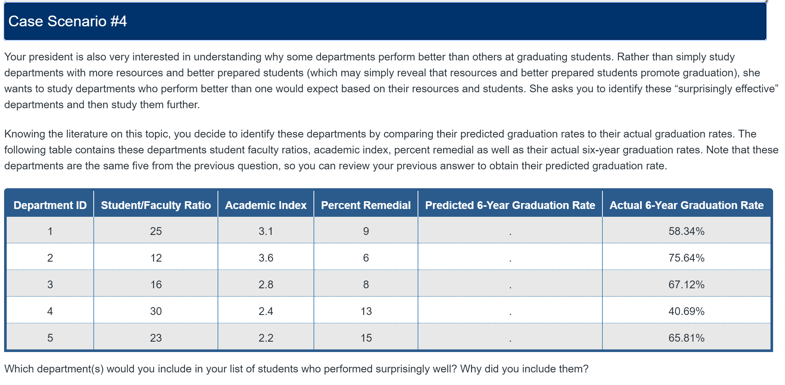

|  |  |  |  |  |  |
| --- | --- | --- | --- | --- | --- |
| **Department ID** | **Student/Faculty Ratio** | **Academic Index** | **Percent Remedial** | **Predicted 6-Year Graduation Rate** | **Actual 6-Year Graduation Rate** |
| 1 | 25 | 3.1 | 9 | 62.2 | 58.34% |
| 2 | 12 | 3.6 | 6 | 82.1 | 75.64% |
| 3 | 16 | 2.8 | 8 | 66.4 | 67.12% |
| 4 | 30 | 2.4 | 13 | 43.8 | 40.69% |
| 5 | 23 | 2.2 | 15 | 43.1 | 65.81% |

Department 5 highly exceeded expectations with an actual 6-year graduation rate increase of 22.7 percent higher than the predicted 6-year graduation rate. This is a significant increase and can likely not be explained by error due to randomness or chance.

Department 3 slightly exceeded expectations with an actual 6-year graduation rate increase of 0.72 percent higher than the predicted 6-year graduation rate. This is likely an insignificant increase as it could be due to error caused by randomness or chance. All other departments achieved actual 6-year graduation rates lower than their predicted graduation rates, so it is reasonable to assume that meeting expectations, like department 3 did, is exceptional during these years.