Personal Reflection: Student Services Available at Meredith College  
Emily Lane  
HIED 545

Option 1: For the institution that you have selected, explore what kinds of student affairs offerings are available to support students. Which students are offered supports? In which ways? How is the institution demonstrating in practice the student affairs theories you have just read about? This information may be found on the institution's website or via marketing materials and articles written about the institution.

Option 2: If you have a contact or are interested in making a connection with a student affairs representative at your selected institution, you may elect to reach out to them. Explore the student affairs offerings available to students. How does their description align with the written narrative? What additional insights did you find?

According to Astin’s theory of student engagement, what students come into higher education with is their “input”, the higher education institution is their “environment”, and their result is the “output”. Meredith College is an all-women’s college, so this is one unifying input quality all students share. Meredith also values traditions which often are activities that serve to unite students within a graduating class over competitions that happen outside of the academic classroom. These traditions provide the foundation for students to unite their individual inputs that they arrived with to the college’s environment through participation in campus wide events. According to Tino, student retention is directly related to student integration, so long as the students’ extracurricular integration does not interfere with their academic endeavors. Meredith’s traditions align with Astin’s theory of student engagement through providing experiences that all students share, and they align with Tino’s theory because they increase student retention.

I have included a list of the various departments at Meredith that provide services to students and have picked a few departments to briefly describe. Figure 1 shows that all services are available for any student with the exceptions of: the study abroad office, which pays special attention to international students; Student Leadership & Service, which members must be elected and approved in order to participate; and the Wings Adult Education program, which only adult learners aged 23+ have access to.

The departments I have mentioned in Figure 1 show Meredith’s commitment to providing a safe, equal, and accessible environment for all of their students. The holistic view of the student that the Student Personnel Point of View (SPPV) emphasizes, “the development of the student as a person rather than upon his intellectual training alone” (Penn, n.d). The student service departments that are available for students do provide support for the nine categories prioritized by the SPPV: intellectually, emotionally, physically, socially, achievements, vocational skills, moral and religious values, economic resources, and aesthetic appreciations (Penn, n.d).

Last semester I have the privilege of interviewing Meredith College’s director of international programs, Dr. Brook Shurer, and various examples she provided involved interdepartmental collaboration. She shared an instance of one student who wanted to study abroad in Spain, but the program required that she share a dorm room with a local student. The Meredith student has disability accommodations set in place at Meredith for a private room, but this was not an option abroad. Dr. Shurer explained that this issue was addressed through collaboration with the student, the counseling center, disability services, residence life, and the study abroad office. A plan was developed through this collaboration that provided suitable coping mechanisms for the student to continue her application to her dream study abroad program, while also following the requirements of a shared room. Dr. Shurer explained that collaboration between departments is incredibly common. This collaboration suggests that there is an emphasis on approaching student affairs issues as a team in order to view each student holistically.

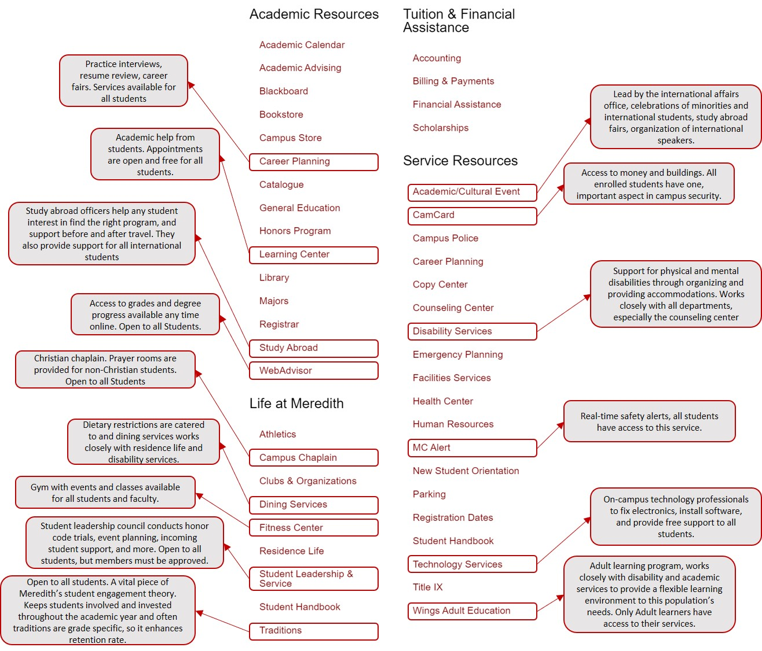**Figure 1**

References:

Penn State World Campus. (n.d.). Lesson 9: Student Affairs as a Means to Student Engagement. In HIED 545: *Foundations of Higher Education and Student Affairs: Spring 2020*. Retrieved from https://psu.instructure.com/courses/2043984/assignments/11272035?module_item_id=27822386

Undergraduate Students. (n.d.). Retrieved March 23, 2020, from https://www.meredith.edu/current-students