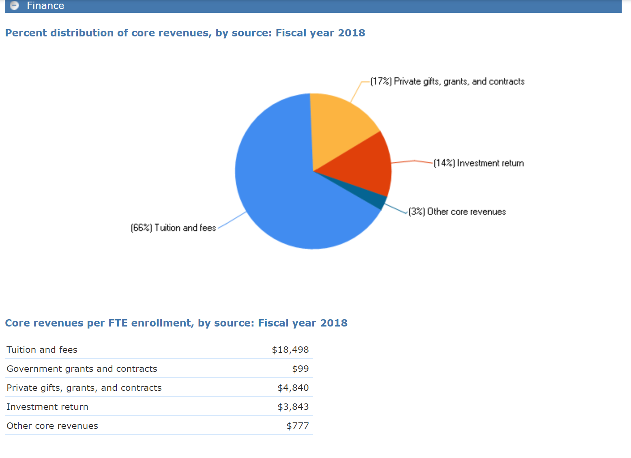

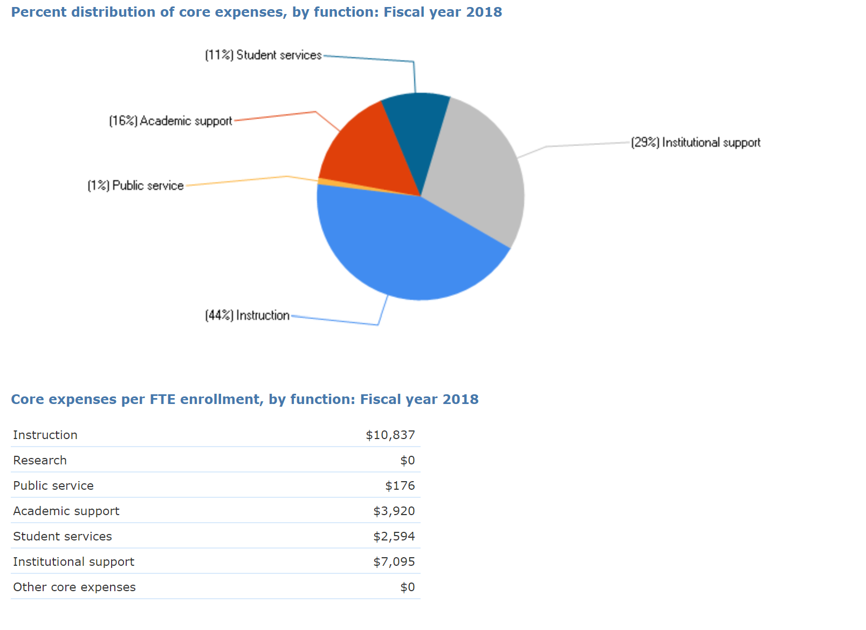

* + What is distinctive about your institution's revenue and expenditure profile?
  + What insights does this profile provide about the nature of your institution?
  + How do you better understand your institution by reviewing the profile of your institution's revenue and expenses?

I reviewed the finances in the IPEDS data set for Meredith College

The largest proportion of Meredith College's revenue comes from tuition and fees (66%) indicating that they are a tuition driven institution. Their second largest source of revenue comes from private gifts and endowment returns (17%). This is not surprising as a primary goal of the president, and the previous three presidents, of the college is growing the endowment. Meredith College also has an extensive network of financially involved alumni which is reflected by its most recent fundraising effort which was the "largest fundraising effort in the history of Meredith College, Beyond Strong" (Meredith, para 1). The campaign began in July 2012 and ended in December 2018 with the goal of raising $75 million, but surpassed its goal by over $15 million with a final amount of $90,466,720. I expect to see an overall growth of private gifts and endowment returns from latter years to present day in Meredith College's revenue profile.

Meredith is a true private liberal arts college in comparison to the example college, Bethel, from the lesson. Their distribution of expenses is very similar to Bethel's differing most in Academic Support where Meredith spends 16% and Bethel spends 8% each fiscal year. The majority of Meredith's budget is spent on Institutional support (29%) and Instruction (44%). This indicates that their primary focuses are supporting, recruiting, and retaining qualified faculty.   
  
There is a substantial portion of the budget utilized for institutional support. This category seems to cover a large variety of expenditures, but a business cannot run smoothly without retaining qualified administrators and providing resources for these professionals to do their job.   
  
I am a bit surprised by the small amount of budget that the student services (11%) and academic support (16%) takes up. Meredith College boasts many clubs, activities, and support for their students, so I expected this to take up a larger portion of the expenditure profile. I am also surprised that $0 are spent on research as Meredith has several laboratories with various new projects being pursued each year. I am interested in finding out what category this research would fall under or how it is funded.

Meredith does not receive any state appropriations or governmental grants and contracts. This indicates that they do not participate in governmentally funded research or training.

I better understand what Meredith College values by their large expenditures on instruction and institutional support. They clearly think that investing in quality teaching and support staff will bring a favorable financial return. They also rely heavily on tuition & fees, endowment return, and private gifts, so investing expenses on quality instruction will eventually generate prepared alumni who will, hopefully, feel grateful to the college. Their financial profile shows forward-thinking and current investment into supporting the long-term goal of a large endowment.