HIED 801   
Week 7: Hypothesis Testing Assignment  
Emily Lane

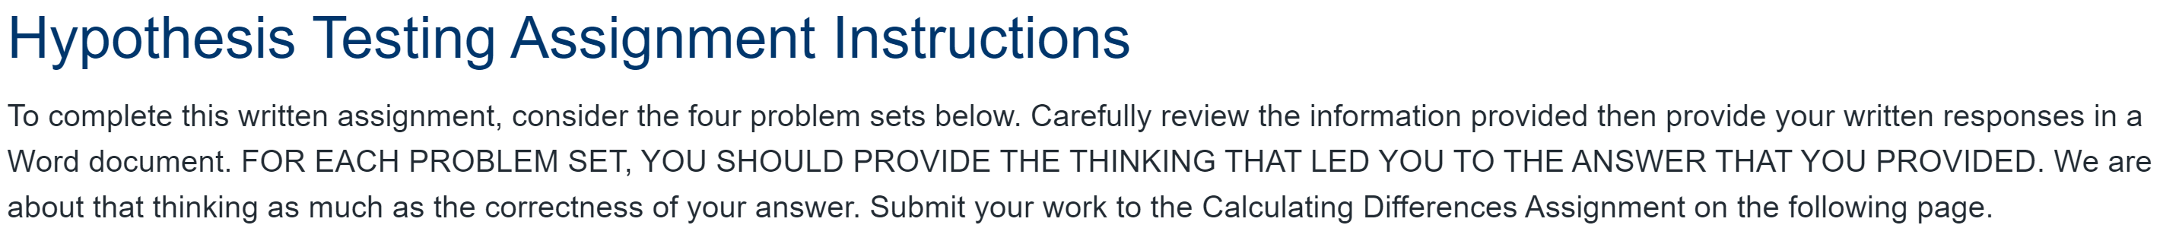

**Question 1:**

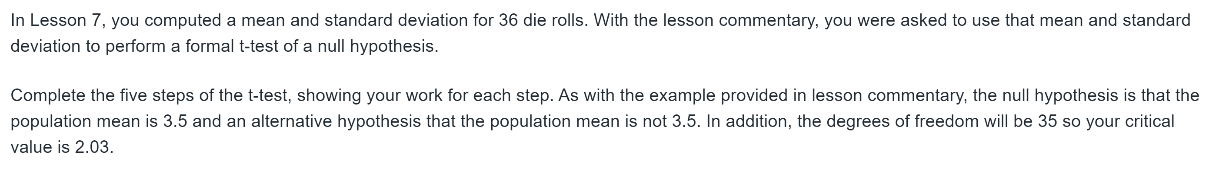

1. Ho (null hypothesis): µ=3.5

Ha (alternate hypothesis): µ≠3.5

1. Critical value T = ±2.03

-based off T distribution with df=35

Meaning that if I get a test statistic with an absolute value larger than 2.03 then we have

evidence to reject the null hypothesis.

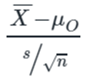

1. Test statistic= = $\frac{sample mean-population mean}{Standard Error}=\frac{3.61-3.5}{\frac{1.81}{\sqrt{36 }}}=0.36$
2. Because the test statistic is less than the Critical Value 2.03, we fail to reject the null hypothesis.

There is insufficient evidence to suggest that the population mean of the rolls of the die is different from 3.5.

*Thought process:

*My sample mean is not far enough away from 3.5 to suggest that the difference in the sample mean and the population mean is due to factors beyond sampling variability.

*Because 3.61 is relatively close to 3.5, we can assume that the difference between the sample man and the expected population mean could be simply due to randomness and chance (sampling variability).

*Sampling variability : If I take multiple samples of size 36, sometimes the mean will be larger than 3.5 and smaller than 3.5 due to chance.

**Question 2:**

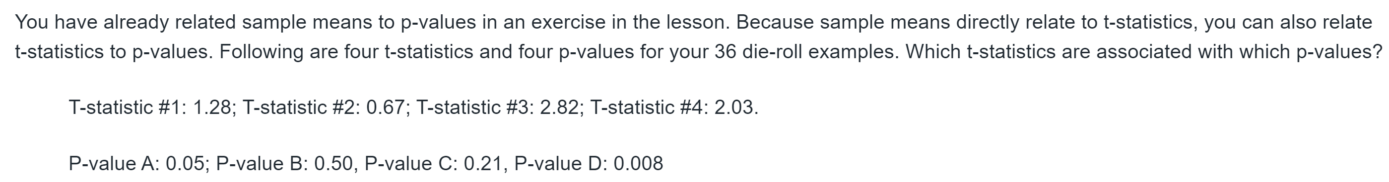

The larger the test statistic (T-statistic) the lower the p-value.

p-value: The probability of observing a sample mean as extreme or more extreme as the one from our sample, assuming that the null hypothesis is true. (the probabilities of the left and right tail added together in a two tailed test)

|  |  |
| --- | --- |
| T-Statistic | P- Value |
| #4: 2.03 | A: 0.05 |
| #2: 0.67 | B: 0.50 |
| #1: 1.28 | C: 0.21 |
| #3: 2.82 | D: 0.008 |

**Question 3:**

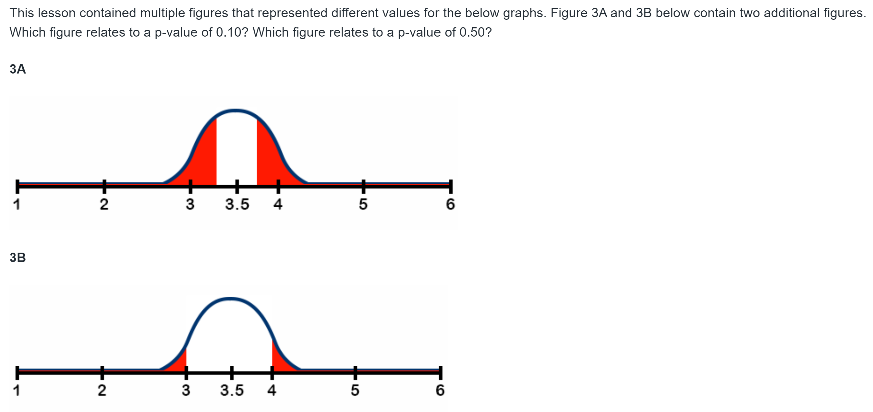

P-value is the shaded area under the curve.

Therefore, Figure 3A relates to a p-value of 0.50 and figure 3B relates to a p-value of 0.10

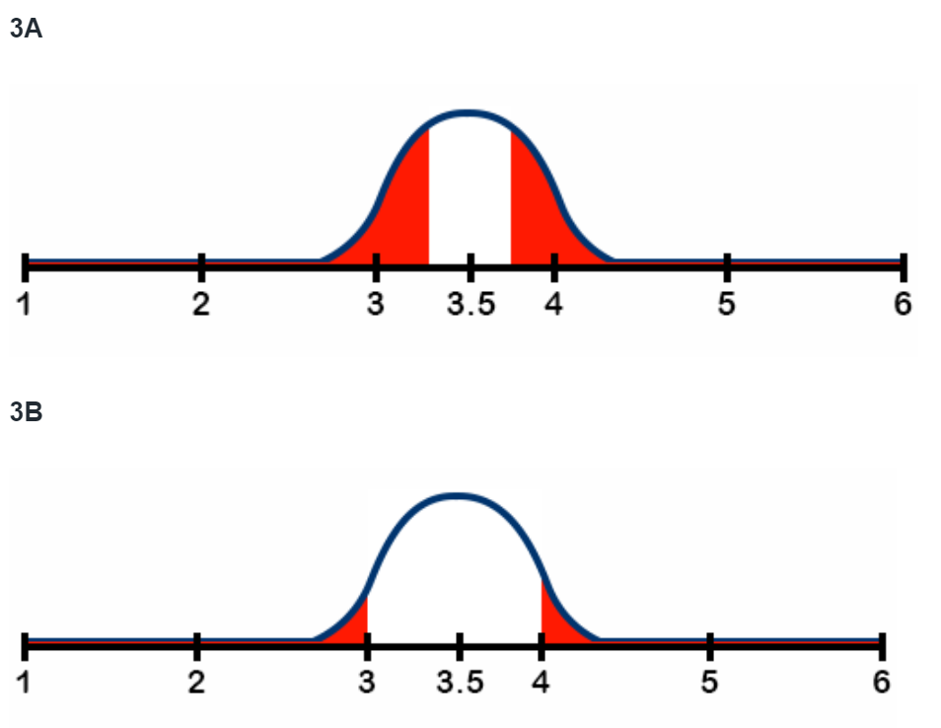



**Question 4:**

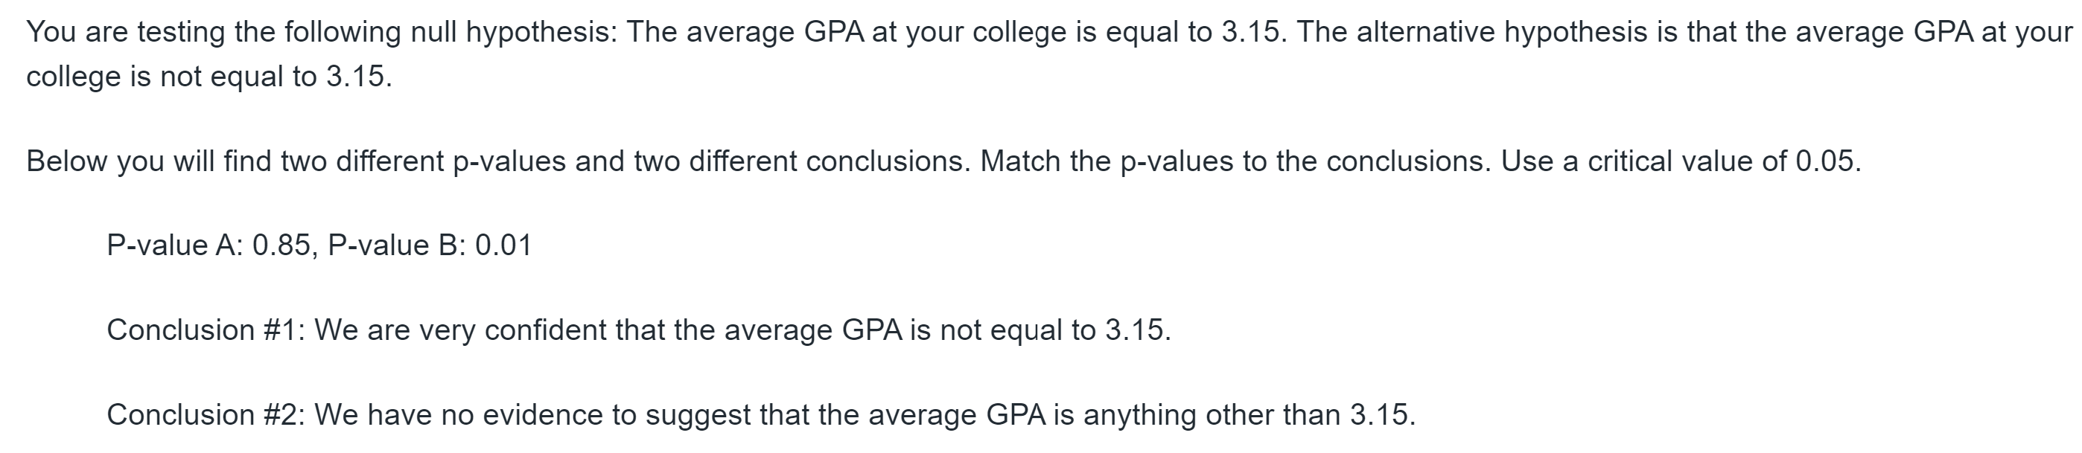

1. Ho (null hypothesis): µ=3.15

Ha (alternate hypothesis): µ≠3.15

1. Conclusion #1: We are very confident that the average GPA is not equal to 3.15

This conclusion rejects the null hypothesis in favor of the alternate hypothesis. This means that the p-value must be very low and less than 0.05

Therefore, it is using P-value B: 0.01

1. Conclusion #2: We have no evidence to suggest that the average GPA is anything other than 3.15

This conclusion fails to reject the null hypothesis in favor of the alternate hypothesis. (In other words, the true mean is still going to be considered 3.15).

Since we failed to reject the null hypothesis, the p-value must be very high and larger than 0.05

Therefore, it is using P-value A: 0.85